Battery Installation Instructions

- Method #1
1 x 16340 Li-ion Recharged Battery
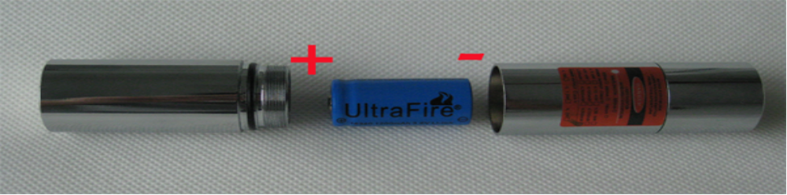
- Method #2 (Recommend)
1 x 18350 Li-ion Recharged Battery
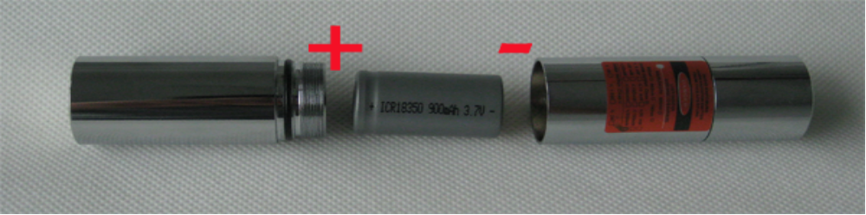

Note:
If you choose Method#2(18350 battery), please make sure the diameter of the 18350 batter is 18mm.
